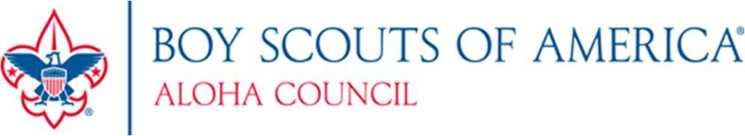

Application for Financial Assistance – Council Program/Insurance Fee 2023 - 2024 Please submit only one application per family

Parent/Guardian (please print clearly)

Address City State Zip

Preferred Telephone Number Email Address

District

Family Members Registered in Scouting

Adults:

Name Position Unit #

Name Position Unit #

Youth:

Name Age Rank Unit #

Name Age Rank Unit #

Name Age Rank Unit #

Name Age Rank Unit #

Statement of Need: Amount Family Is Able To Provide $ Amount Unit Is Able To Provide $

Our unit participates in (check all that apply): [ ] Popcorn Sale [ ] Camp Card Sale [ ] Summer Camp/Day Camp Amount of Financial Assistance Requested: $ (Council Program/Insurance Fee = $57.00 per registered youth)

As a parent or guardian of the above-named individual(s), I certify that the financial aid requested is needed: Parent/Guardian Signature Date

Unit Committee Approval

I have reviewed this application and verify these Scouts are registered in my unit, in good standing, and deserving of the assistance requested:

Signature Date

Printed Name Position in the Unit

Council Approval

Approved: Yes No Amount Approved $ By: